1. **Web Api using .Net core with Swagger**

Create a .Net core web application with API template. (Use existing application if created). Install Swashbuckle.AspNetCore Nuget package. Post this do the following steps in Startup.cs

1. Execute the application which will load the default ‘Values’ controller(Settings as per launchSettings.json) GET action method. Change the url to <https://localhost:[port> number]/swagger

Notice the Title, Version, Contact detail provided shown on the top of the page

Notice the Values controller HttpVerb action methods getting listed.

Click the ‘GET’ action verb method(Without the parameter).

It opens a panel which has ‘Try it out’ button. Click that and Click ‘Execute’ button.

1. Use POSTMAN tool, to point to the local Web API that was created with Employee controller. Test the GET action method using POSTMAN.

Verify the output if the List of employees are listed in the ‘Body’ part of the GET window on POSTMAN tool.

Verify the Status on the right side of the output pane on POSTMAN tool.

1. Modify the Controller name in the Route attribute of the Employee controller to ‘Emp’ and check its access thru POSTMAN

CODE:

Program.cs

var builder = WebApplication.CreateBuilder(args);

// Add services to the container.

builder.Services.AddControllers();

builder.Services.AddEndpointsApiExplorer();

builder.Services.AddSwaggerGen(c =>

{

c.SwaggerDoc("v1", new Microsoft.OpenApi.Models.OpenApiInfo

{

Title = "Swagger Demo",

Version = "v1", // Change from "1.0" to "v1"

Description = "TBD",

TermsOfService = new Uri("http://www.example.com"),

Contact = new Microsoft.OpenApi.Models.OpenApiContact

{

Name = "John Doe",

Email = "john@xyzmail.com",

Url = new Uri("http://www.example.com")

},

License = new Microsoft.OpenApi.Models.OpenApiLicense

{

Name = "License Terms",

Url = new Uri("http://www.example.com")

}

});

});

var app = builder.Build();

// Configure the HTTP request pipeline.

if (app.Environment.IsDevelopment())

{

app.UseSwagger();

app.UseSwaggerUI(c =>

{

c.SwaggerEndpoint("/swagger/v1/swagger.json", "Swagger Demo"); // Ensure this matches the Title

});

}

app.UseHttpsRedirection();

app.UseAuthorization();

app.MapControllers();

app.Run();

EmployeeController.cs

using Microsoft.AspNetCore.Mvc;

using System.Collections.Generic;

namespace MyWebApi.Controllers

{

[Route("api/Emp")]

[ApiController]

public class EmployeeController : ControllerBase

{

private List<Employee> GetStandardEmployeeList()

{

return new List<Employee>

{

new Employee { Id = 1, Name = "John Doe", Salary = 50000, Permanent = true, Department = new Department { Id = 1, Name = "IT" }, Skills = new List<Skill> { new Skill { Id = 1, Name = "C#" } }, DateOfBirth = new System.DateTime(1990, 1, 1) },

new Employee { Id = 2, Name = "Jane Smith", Salary = 60000, Permanent = false, Department = new Department { Id = 2, Name = "HR" }, Skills = new List<Skill> { new Skill { Id = 2, Name = "HRM" } }, DateOfBirth = new System.DateTime(1985, 5, 10) }

};

}

[HttpGet]

[ProducesResponseType(StatusCodes.Status200OK)]

public ActionResult<List<Employee>> GetStandard()

{

return Ok(GetStandardEmployeeList());

}

[HttpGet("ByName")]

[ActionName("GetByName")]

[ProducesResponseType(StatusCodes.Status200OK)]

public ActionResult<List<Employee>> GetByName()

{

return Ok(GetStandardEmployeeList());

}

}

public class Employee

{

public int Id { get; set; }

public string Name { get; set; }

public int Salary { get; set; }

public bool Permanent { get; set; }

public Department Department { get; set; }

public List<Skill> Skills { get; set; }

public DateTime DateOfBirth { get; set; }

}

public class Department

{

public int Id { get; set; }

public string Name { get; set; }

}

public class Skill

{

public int Id { get; set; }

public string Name { get; set; }

}

}

Test with EmployeeController

1. Swagger

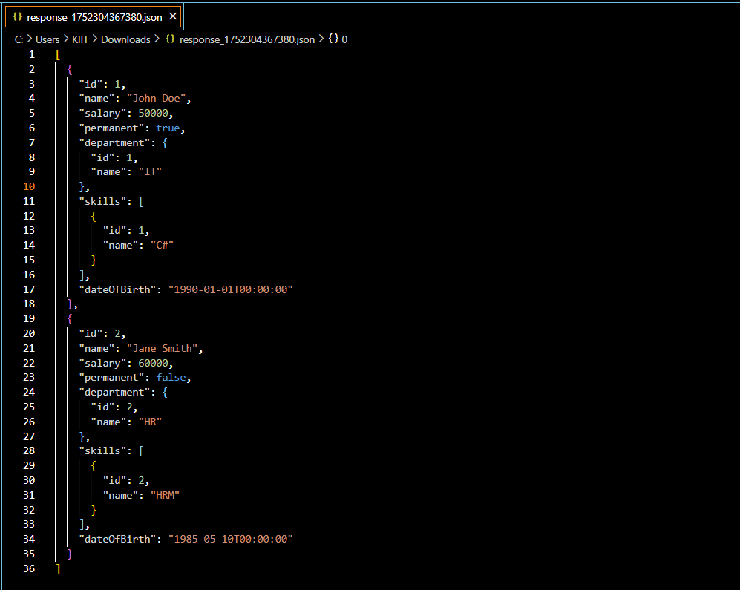 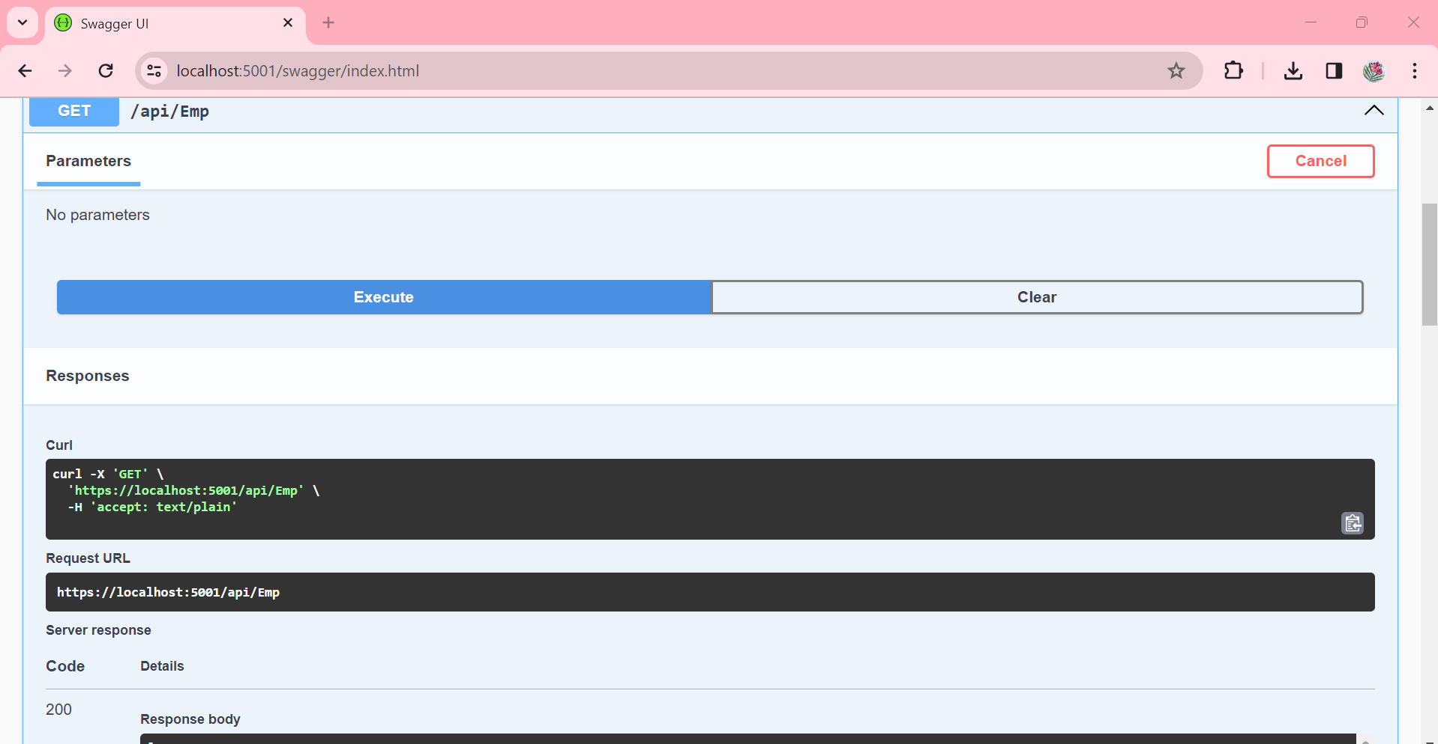

1. Postman

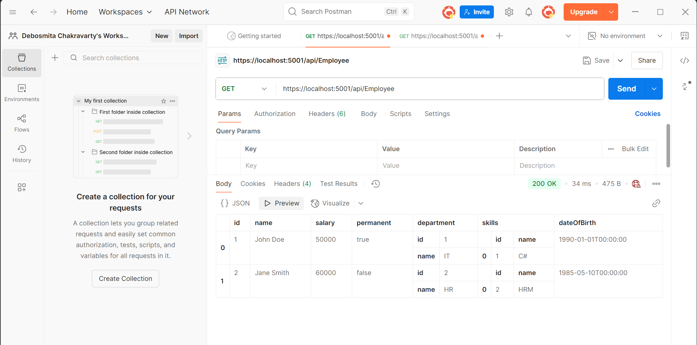

1. Route is modified to [Route("api/Emp")]
2. ActionName Demo
3. Swagger

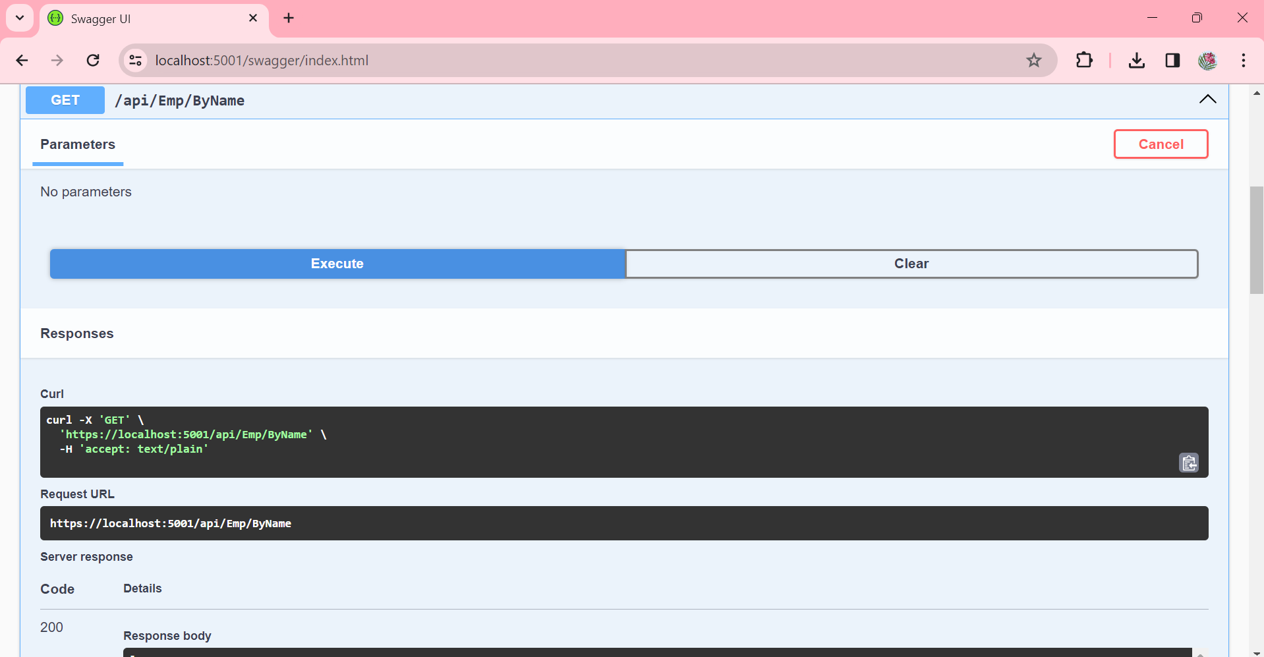



1. Postman

